Lunch Menu
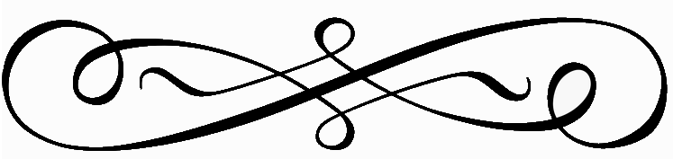 Starters
House Salad - $7 Caesar Salad - $8 Soup of the Day - $7
Chilled Shrimp Cocktail - $18
3 Chilled Jumbo Shrimp, Cocktail Sauce, Citrus Gel

Entrée Salads
Victoria Bowl - Romaine Lettuce, Chicken, Shredded Pepper Jack Cheese, Chopped Bacon, Baby Tomatoes, Poppy Seed Dressing Pita - $22

Caesar Salad – Romaine, Parmesan Cheese Garlic Croutons, Classic Caesar Dressing - $12
Chicken $18 Salmon $24 Shrimp $22 Side of Anchovies $2.50

Pan Roasted Salmon Salad - Romaine, Smoked Candied Bacon, Pickled Red Onion, Cherry Tomatoes, Gorgonzola Vinaigrette - $24

Roasted Beet and Goat Cheese - Wild Baby Arugula, Avocado, Candied Walnuts, Extra Virgin Olive Oil, Aged Balsamic - $18

Traditional Cobb Salad - Romaine, Diced Chicken, Smoked Bacon, Tomato, Avocado, Egg and Bleu Cheese Crumbles Over Hearts of Romaine - $22

Burgers, Sandwiches & Entrees
Burgers and Sandwiches are Served with Your Choice of House Salad, French Fries or Fruit
Victoria Burger – Cheddar, Bacon, Lettuce, Marinated Tomato, Onion Marmalade,1000 Island, Brioche Bun - $21 Sub Impossible Patty – add $4

Grilled Ham and Cheese – Black Forest Ham, Gruyere Cheese, Whole Grain Mustard, Caramelized Onion, Sliced Brioche - $14

Turkey Malibu - Ortega Chiles, Jack Cheese & Avocado on Toasted Sourdough - $14

The B.L.T.A – Smoked Bacon, Marinated Tomato, Lettuce, Crushed Avocado, Sourdough - $14

Cheese Quesadilla – Flour Tortilla, Cheese Blend, Salsa, Guacamole, Sour Cream - $10
Add Chicken $16 Add Shrimp $20 Add Steak $21

Steak Frites - Grilled Prime Flat Iron Steak, Rosemary Pomme Frites, Reduction - $32

Cheese Tortellini alla Vodka - Pancetta, English Peas, Tomato Vodka Sauce, Parsley - $21

Pizzas
All Items Include Pomodoro Sauce and Shredded Mozzarella
Cheese Only - $9
Pepperoni - $12
Pepperoni, Sausage, and Onion - $14
Peppers, Onions, and Mushrooms - $12
Add Extra Cheese - $3

Snacks

Sweet Potato Fries - $5
Seasoned Waffle Fries - $5
Regular Fries - $5
Fresh Fruit - $6

