Terrace Takeout
Call 951-683-5323 x244 to place order.
Orders may be placed Tuesday – Friday
starting at 11am for food delivery 12-4pm

Cobb Salad - Ham, Turkey, Applewood Smoked Bacon, Tomato, Avocado, Egg and Bleu Cheese Crumbles Over Hearts of Romaine - $14

French Dip - Thinly Sliced Prime Rib, Grand Cru Cheese, Au Jus - $17

VC Grilled Chicken Quesadilla Flour Tortilla, Chicken, Jack Cheese, Pico De Gallo, Chipotle, Guacamole & Sour Cream - $12
Cheese Only $8, Steak $15, Shrimp $18

Chicken Strips 5 Hand-breaded Tenders served with Dipping Sauce and Fries - $10

Pizza – Your Choice of Cheese, Thick Sliced Pepperoni or Sausage - $12

Chips with Salsa - $5

French Fries - $5

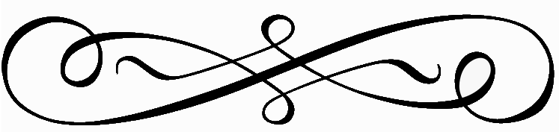
Terrace Takeout
Call 951-683-5323 x244 to place order.
Orders may be placed Tuesday – Friday
starting at 11am for food delivery 12-4pm

Cobb Salad - Ham, Turkey, Applewood Smoked Bacon, Tomato, Avocado, Egg and Bleu Cheese Crumbles Over Hearts of Romaine - $14

French Dip - Thinly Sliced Prime Rib, Grand Cru Cheese, Au Jus - $17

VC Grilled Chicken Quesadilla Flour Tortilla, Chicken, Jack Cheese, Pico De Gallo, Chipotle, Guacamole & Sour Cream - $12
Cheese Only $8, Steak $15, Shrimp $18

Chicken Strips 5 Hand-breaded Tenders served with Dipping Sauce and Fries - $10

Pizza – Your Choice of Cheese, Thick Sliced Pepperoni or Sausage - $12

Chips with Salsa - $5

French Fries - $5

