Brunch Menu
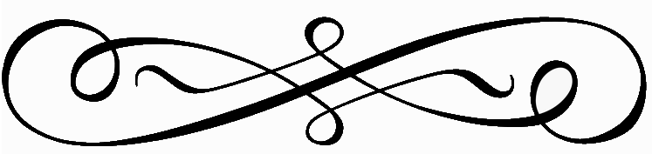 Eggs and Griddle Items

Victoria Eggs Benedict $15
2 Poached Eggs, English Muffin, Black Forest Ham, Hollandaise, Hashbrowns or Home Fries Sub Smoked Salmon add $6

2 Egg Breakfast $12
Two Eggs Any Style, Choice of Bacon or Sausage, Choice of Pancake or Toast, Hashbrowns or Home Fries

Breakfast Burrito $14
Scrambled Eggs, Bacon, Sausage, Potato, Cheddar Cheese, Pico de Gallo, Guacamole

The Works “Skillet Style” Breakfast $15
2 Eggs Any Style, Home Fries, Peppers, Sausage, Smoked Bacon, Balsamic Onions, Shredded Jack Cheese

Smoked Bacon & Cheddar Omelet $12
Hash Browns or Home Fries

Black Forrest Ham Omelet $14
Bell Pepper, Jack Cheese, Hash Browns or Home Fries

Sweet Cream Pancake Stack $12
Four Pancakes, Bacon or Sausage, Maple Syrup, Butter Add Blueberries $3

Brioche French Toast $11
Apple Compote, Maple Syrup, Powdered Sugar

Apple Crepes $10
3 Crepes, Mascarpone Cheese, Apple Compote, Powdered Sugar

Salads, Sandwiches & Entrees

Smoked Salmon, Cream Cheese, Tomato, Pickled Onion, Capers & Mini Bagel $14

Traditional Cobb Salad $22
Romaine, Diced Chicken, Smoked Bacon, Tomato, Avocado, Egg and Bleu Cheese Crumbles Over Hearts of Romaine

Pan Roasted Salmon Salad $24
Romaine, Smoked Candied Bacon, Pickled Red Onion, Cherry Tomatoes, Gorgonzola Vinaigrette

Steak and Eggs $32
Two Eggs Any Style, 8 Ounce Prime Flat Iron Steak, Hashbrowns or Home Fries

Chicken and Waffle $14
Three Fried Chicken Tenders, Sweet Pearl Waffle, Maple Syrup, Honey

Grilled Ham and Cheese $14
Black Forest Ham, Gruyere Cheese, Whole Grain Mustard, Caramelized Onion, Sliced Brioche

The B.L.T.A $14
Smoked Bacon, Marinated Tomato, Lettuce, Crushed Avocado, Sourdough

Steak Frites -Grilled Prime Flat Iron Steak, Rosemary Pomme Frites, Reduction -$32

Cheese Tortellini alla Vodka $21
Pancetta, English Peas, Tomato Vodka Sauce, Parsley

Sides & Accompaniments

Extra Egg $2.50
Bacon (4 Pieces) $4
Sausage Link (4 Pieces) $4
Impossible Patty $4
Small Sliced Seasonal Fruit $6
Side of Pancake (2) $4
Toast or English Muffin $2.50
Side of Hashbrown or Home Fries $3

